**Correlations**

Enter your data remembering that X and Y need to paired (i.e. don’t rearrange the order of the rows).

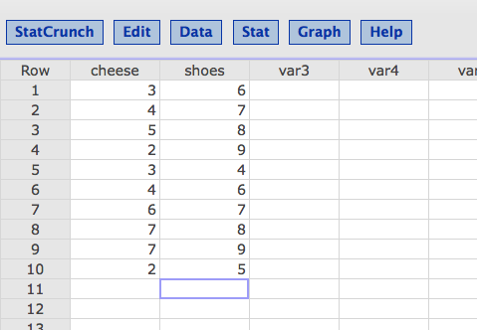

Click “Stat” then “Summary Stats” and then select “Correlation”

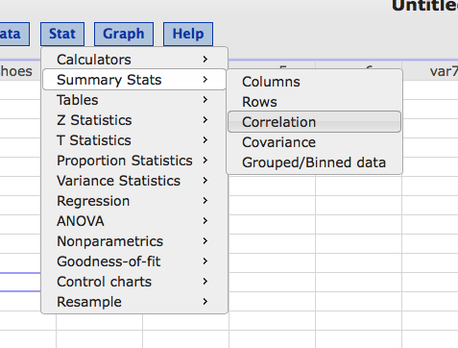

Hold down the “shift” key and click on all of the variables you wish to run correlations on.

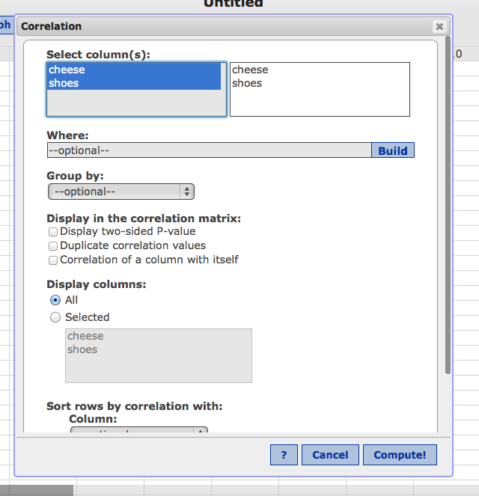

Click “Compute”

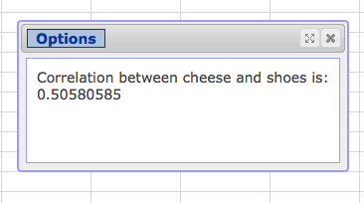

Here is your *r* value for step 2.

**Scatterplots**

Click “Graph” and then select “Scatter Plot”

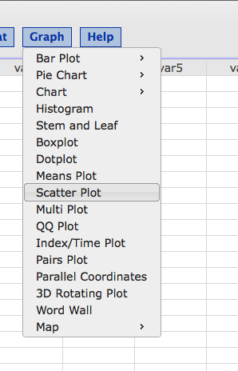

Select a variable for X and a variable for Y.

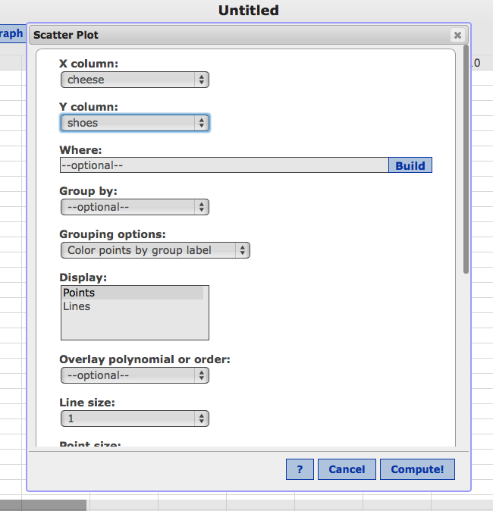

Hit compute!

Remember, if you label the columns it will show up on the graph.

